LIT 146G: Victorian Prose

Queer(y)ing Victorian Literature

Instructor Tara Thomas – Spring 2019

Time: MWF 2:40-3:45 E-mail: tanthoma@ucsc.edu
Location: Merrill Acad. 130 Office: HUM 329
Office Hours: Mondays 1-2 p.m.

Required Texts
- Charles Dickens, The Mystery of Edwin Drood
(Penguin Classics 0140439269)
- Sheridan Le Fanu, Carmilla
(Syracuse University Press 0815633112)
- Robert Louis Stevenson, The Strange Case of Dr. Jekyll and Mr. Hyde
(Dover Thrift 0486266885)
- Oscar Wilde, The Picture of Dorian Gray
(Oxford World’s Classics 0199535989)
- Sarah Waters, Tipping the Velvet
- Course Reader (materials also available on Canvas)

Course Description

The Victorian era in the popular imaginary are often viewed as a period of social conformity, establishing gender hierarchies and reinforcing heteronormativity. Gender and sexuality studies have critiqued the perpetuation of nineteenth-century England as a homogenized society, demonstrating the ways in which the Victorians were not sexually repressed, how queer, counternormative culture thrived, and how popular culture was at times comfortably queer. This course turns to fiction in mid-to-late-nineteenth-century England to survey representations of non-normative gender and sexuality in popular culture. We will consider the extent to which representations of non-normative, transgressive figures in fiction conform to or resist established perceptions of gender, sexuality, race, and empire. Because our inquiry is both historical and theoretical, our supplementary readings draw both from nineteenth-century and modern critical essays on gender and sexuality.

We will examine authors such as Charles Dickens, Robert Louis Stevenson, and Oscar Wilde, putting popular fiction into conversation with sexologists like Havelock Ellis and Sigmund Freud, as well as modern queer theorists like Michel Foucault, Eve Kosofsky Sedgwick, and Sara Ahmed. We begin by discussing the racialized homophobia and suppressed homoeroticism in Charles Dickens’s final, unfinished novel, The Mystery of Edwin Drood, before turning to representations of same-sex desire between women in Carmilla, before moving on to discuss changing attitudes about deviant gender and sexuality that led to the criminalization of homosexuality between men with the passage of the Labouchere Amendment in 1885. This leads us to consider the effects criminalization had on literature at the time: from the use of literature as evidence of ‘sexual inversion’ with Dorian Gray. We will explore the ways in which the Victorians blatantly disregarded efforts to criminalize same-sex desiring and gender non-conforming people in late-Victorian decadent literature by Max Beerbohm and Vernon Lee. Then we will examine representations of queerness in the empire in Victoria Cross’s “Theodora” before turning to the neo-Victorian novel, Sarah Water’s Tipping the Velvet, to discuss representations of same-sex desire and gender performativity.

Course Goals

As an upper-division seminar in the Literature Department, this course will familiarize you with critical thinking, reading, and writing skills honed through the opportunity to research queer studies and the Victorian novel in great depth. Throughout the course, we will work toward the following goals:

Critical analysis:
- To understand the formal structures, genres, and rhetorical strategies of different kinds of writing (specifically, the novel form and critical essay), discourse, and media.
- To understand the historical contexts of such texts.
- To understand the role cultural and linguistic difference play in the interpretation of texts (in this case, we will pay attention to the language Victorians use to speak about sexual and gender non-conformity).
Critical reading:
- To evaluate multiple interpretations of texts.
- To situate texts in relation to a critical/theoretical tradition.
Critical research:
- To design and initiate a substantive independent project of research or creative activity.
- To engage in thoughtful discussion of texts through provocative and pertinent questions in order to broaden our collective interpretations of these texts.

Course Responsibilities and Final Grading

Your final grade in the course will be determined as follows:
- Short Essay 15%
- Special Collections Assignment 10%
- Weekly Reading Quizzes 25%
- Final Project 30%
- Participation 20%

Overview of Assignments (specific prompts to be handed out)

Short Essay: Your first assignment will be a 2-3 page essay analyzing either Edwin Drood or Carmilla. I will ask you to pick one of the critical essays we have read thus far in class and apply it to your analysis of the text.

Special Collections Assignment: On Week 8, we will visit McHenry’s Special Collections to view some first editions of the literature we are reading this term, as well as other Victorian texts of interest to us this term. This assignment is a short (1-2 pages) reflection on the relation between the paratext and text of the book or periodical you study at McHenry, and should reflect on how surrounding elements like illustrations and advertisements effect our reading of the text’s representations of gender and sexuality.

Weekly Reading Quizzes: In lieu of a midterm or final, we will have weekly reading quizzes worth 25% of your final grade. These are meant to help guide your understanding of the texts we read, so that you develop your critical reading skills over the course of the term. You will have ten minutes to answer five questions; each quiz will be five points except the final two, which will each be worth ten. They will be given in class either Wednesday or Friday on Canvas, so download the Canvas app on your phone or bring your laptop to class with you. You will not be permitted to make up quizzes if you miss class that day.

Final Project: The final project for this class will be a museum exhibition on “Queer Victorian Literature and Culture” that we design together using Omeka to create a digital archive. I will divide the course into small groups and each group will create an exhibition collection that will feature literary and art objects. Students will write descriptions and analyses of each of the objects in addition to a co-written introduction to the collection.

***All assignments must be completed in order to pass the class. No late work will be accepted, nor will I allow make up quizzes***

Class Policies

Participation and Attendance:
As a seminar, this course is largely based on discussion, the quality of which depends on your preparedness and willingness to engage in class discussion. It is necessary to be punctual, to be present, and to participate in class. Failure to show up prepared will be reflected in your Weekly Reading Quiz (25%) and Participation (20%) grades. Attendance is mandatory. More than three absences will result in failure of the Participation grade. More than six absences will result in automatic failure of this course.

Communication: I will be communicating with you on Canvas and through UCSC email to alert you of any announcements, changes to the schedule, or other comments. Be sure to check your UCSC email regularly. Email me with any concerns, emergencies, questions, or to set up a meeting outside of office hours.

Assignment Submission and Late Work: Assignments should be submitted as per the instructions on the assignment handout. Late work will not be accepted, except in the case of an emergency. All assignments should follow MLA format, with 1-inch margins, double-spaced, in 12 pt Times New Roman. Refer to the Purdue Owl website for details on MLA format (https://owl.english.purdue.edu/owl/resource/747/01/)

Academic Integrity: Plagiarism will result in an automatic failure of this course, and may be submitted to the student’s provost and Academic Misconduct Committee. UCSC defines plagiarism as follows: “the use of intellectual material produced by another person without acknowledging its source.”

Resources

Disability Resource Center (DRC): If you qualify for accommodations due to a disability, please get an Accommodation Authorization form from DRC & submit it to me at the beginning of the term. Contact the DRC at (831)459-4806 or http://drc.ucsc.edu/ for more information.

Writing Tutoring: I strongly encourage you to visit one of the writing centers on campus for help with your writing. Tutoring is available through Learning Support Services (https://lss.ucsc.edu). Tutors can help you improve your writing and critical thinking skills, so even if you already write well, consider using this free resource.

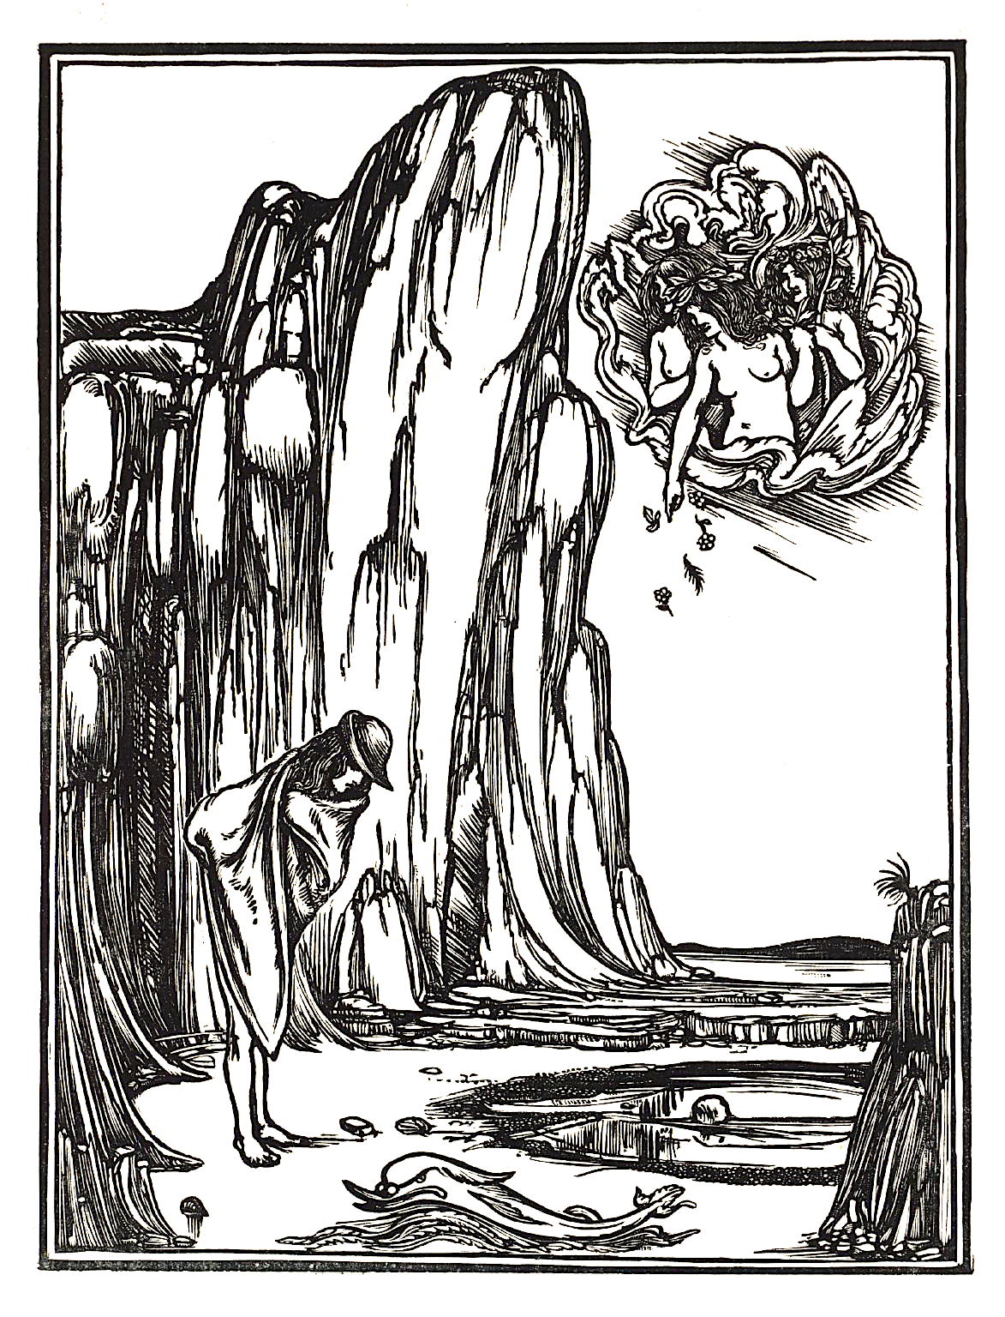

Due Dates and Reading Schedule

WEEK 1 | INTRODUCTION: SEXOLOGY, QUEER THEORY AND VICTORIAN GENDER & SEXUALITY
Monday  4/1/19 | Course Introduction: Queer, Victorian Studies  In-Class Reading:  Havelock Ellis & John Addington Symonds, Sexual Inversion  Edward Carpenter, The Intermediate Sex
Wednesday  4/3/19 | Charles Dickens, The Mystery of Edwin Drood (1-4)  Keywords: sexual inversion, homosexuality, degeneration, decadence
Friday  4/5/19 | Charles Dickens, The Mystery of Edwin Drood (ch. 5-9)  Gayle Rubin, “Thinking Sex,” The Lesbian and Gay Studies Reader  Keywords: (linguistic, gender) performativity, lesbian, gender/sexual hierarchies, universality, drag
WEEK 2 | HOMOPHOBIA AND THE VICTORIANS
Monday  4/8/19 | Charles Dickens, The Mystery of Edwin Drood (ch. 10-15)  Sigmund Freud, “I: Sexual Aberrations,” Three Essays
Wednesday  4/10/19 | Charles Dickens, The Mystery of Edwin Drood (ch. 16-20)  Strike: No Class. Character Description Assignment due on Canvas
Friday  4/12/19 | The Mystery of Edwin Drood (ch. 21-end)  Eve Kosofsky Sedgwick, Between Men, “Up the Postern Stair: Edwin Drood and the Homophobia of Empire”  Keywords: homo/heterosexual binary, homosocial, homosexual panic, erotic triangle, racialized homosexuality, heterosexual plot, Englishness
WEEK 3 | SAME-SEX DESIRE, WOMEN, AND THE VAMPIRE
Monday  4/15/19 | Sheridan Le Fanu, Carmilla (Prologue-Chapter 3)  Michel Foucault, History of Sexuality vol. 1 (“Part one: We Other Victorians” (read carefully), skim Part two “The Repressive Hypothesis” and Part three “Scientia Sexualis”)  Keywords: repression, sublimation, normative sexuality, sexual inversion
Wednesday  4/17/19 | Sheridan Le Fanu, Carmilla (Chapter 4-9)
4/19/19 | Sheridan Le Fanu, Carmilla (Chapter 10-end)  Sue-Ellen Case, “Tracking the Vampire”  Keywords: lesbian, queer desire, same-sex desire, (un)natural, Oedipal  triangle, heterosexual gaze, the phallus, the uncanny, jouissance
WEEK 4 | HYSTERIA AND SEXUALITY
Monday 4/22/19 | Short Essay Due  In-Class Reading: Eve Kosofsky Sedgwick’s “Epistemology of the Closet”
Wednesday  4/24/19 | Robert Louis Stevenson, The Strange Case of Dr. Jekyll and Mr. Hyde (1-24)
Friday  4/26/19 | Robert Louis Stevenson, The Strange Case of Dr. Jekyll and Mr. Hyde (25-54)  Keywords: hysteria, queer codification of language, sexology and pseudoscientific classification, contagion, perversion
WEEK 5 | QUEERNESS AND EMPIRE
Monday  4/29/19 | Vernon Lee, “A Wicked Voice”
Wednesday  5/1/19 | Vernon Lee, “Dionea”
Friday  5/3/19 | Victoria Cross, Theodora, a Fragment  Sara Ahmed, Queer Phenomenology, “The Orient and Other Others” (selections)  Jack Halberstam, In a Queer Time and Place (selections)  Keywords: gothic, imperialism, other, orientalism
WEEK 6 | QUEER AESTHETICS
Monday  5/6/19 | Oscar Wilde, The Picture of Dorian Gray (ch. 1-3)  Max Nordau, Degeneration, “The Decadents and the Aesthetes”
Wednesday  5/8/19 | Oscar Wilde, The Picture of Dorian Gray (ch. 4-6)
Friday  5/10/19 | Oscar Wilde, The Picture of Dorian Gray (ch. 7-8)
WEEK 7 | CRIMINALIZATION OF HOMOSEXUALITY
Monday  5/13/19 | Oscar Wilde, The Picture of Dorian Gray (ch. 9-13)  Joseph Bristow, “Wilde, Dorian Gray, and Gross Indecency”  Keywords: gross indecency, sexual difference, Labouchere Amendment
Wednesday  5/15/19 | Oscar Wilde, The Picture of Dorian Gray (ch. 14-16)
Friday  5/17/19 | Oscar Wilde, The Picture of Dorian Gray (17-end)
WEEK 8 | SPECIAL COLLECTIONS
Monday  5/20/19 | Special Collections Day I: Group 1 will attend Special Collections with me, while Group 2 attends Omeka online training at the Digital Scholarship Commons.
Wednesday  5/22/19 | Special Collections Day II: Group 2 will attend Special Collections with me, while Group 1 attends Omeka training at the Digital Scholarship Commons.
Friday  5/24/19 | Queer Poetry (readings in class) & Final Project Workshop  Neologism Assignment  Special Collections Assignment due by midnight
WEEK 9 | GENDER, SEXUALITY, FEMINISM
Monday  5/27/19  Holiday | No Class  Begin reading Tipping the Velvet
Wednesday  5/29/19 | Sarah Waters, Tipping the Velvet (ch 1-4)
Friday  5/31/19 | Sarah Waters, Tipping the Velvet (ch 5-end of part 1)
WEEK 10 | (NEO)VICTORIAN FEMALE MASCULINITY
Monday  6/3/19 | Sarah Waters, Tipping the Velvet (Part 2)  Robyn Wiegman, Object Lessons, “Telling Time: When Queer Theory and Feminism Diverge”  Keywords: (19th and contemporary) female masculinity, gender and sexual codes, tribade (in sexology), androgyne
Wednesday  6/5/19 | Sarah Waters, Tipping the Velvet (ch 15-17)  Jack Halberstam, Female Masculinity, “The Androgyne, the Tribade, the  Female Husband”
Friday  6/7/19 | Sarah Waters, Tipping the Velvet (ch 18-end)

FINAL PROJECT

DUE BY 11 A.M.
Wednesday, June 12th

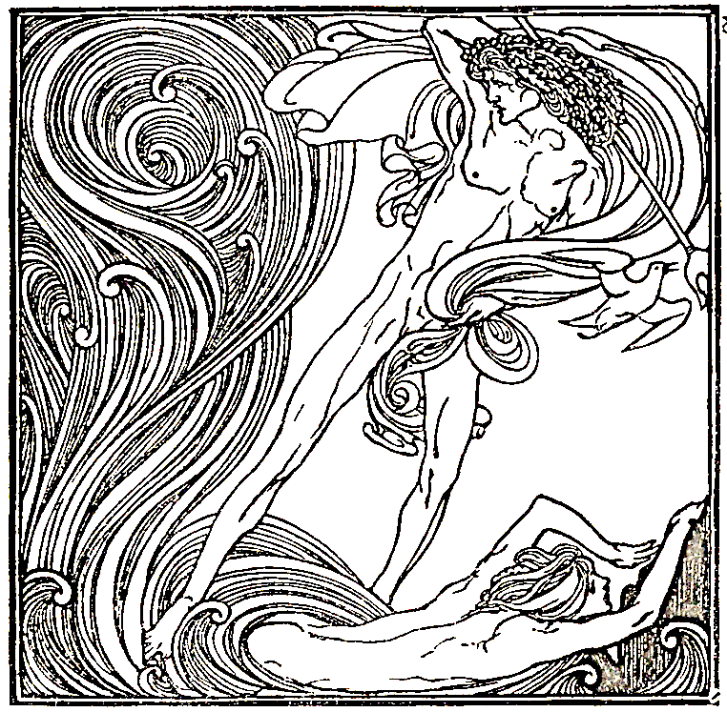
Timeline:
1870: The Mystery of Edwin Drood, Charles Dickens
1872: Carmilla, Sheridan Le Fanu
1873: Male Love: A Problem in Greek Ethics, John Addington Symonds (later printed as first chapters of Sexual Inversion)
1886: The Strange Case of Dr. Jekyll and Mr. Hyde, Robert Louis Stevenson
1890: The Picture of Dorian Gray, Oscar Wilde
Hauntings and Other Fantastic Stories, Vernon Lee
1892: Degeneration, Max Nordau
1897: Sexual Inversion, Havelock Ellis
1905: Three Essays, Sigmund Freud
1908: The Intermediate Sex, Edward Carpenter
1976: The History of Sexuality, vol. i, Michel Foucault
1984: “Thinking Sex,” Gayle Rubin
1985: Between Men, Eve Kosofsky Sedgwick
1990: Epistemology of the Closet, Eve Kosofsky Sedgwick
1991: “Tracking the Vampire,” Sue Ellen Case
1994: Sexual Sameness, Joe Bristow
1998: Tipping the Velvet, Sarah Waters
Female Masculinity, Jack Halberstam
2006: Queer Phenomenology, Sara Ahmed
2007: Between Women, Sharon Marcus
2012: Object Lessons, Robyn Wiegman

