ASSIGNMENT: MULTISPECIES ETHNOGRAPHY

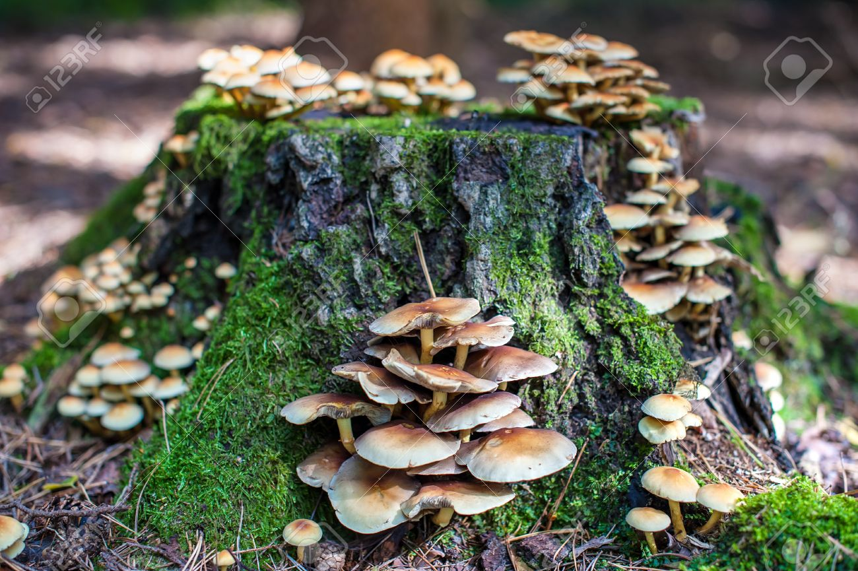

DUE BY EMAIL, 5 PM, TUESDAY, October 1 [There is no class this day]

Multispecies Ethnography. (4-5 pages, double spaced.) Guidelines are forthcoming for this exercise, which will ask you to use advanced descriptive techniques to examine carefully and with technical specificity a given relational ecosystem or part of one. The object of your analysis need not be “natural,” but must account for relations among human and nonhuman actors at multiple scales. This is an exercise in faithful and detailed descriptive writing.

What is a multispecies ethnography? In short: it is a written record of the interconnection of human and nonhuman beings in a given place or locale. Think of it as a close reading of a place. The guiding ethic of this project is specificity: your description should be detailed and scientifically specific, giving species names, information about them, and carefully researched details about the beings convened in your chosen space. There are many ways to do this. Your writeup need not be driven by a thesis, and it can be creative in its format and approach. It is not a five paragraph essay in the normal mode! Think of the writerly form that would be most appropriate for evoking and specifically describing your site.

What am I supposed to do? First, pick a place. This should be a specific place that you think would repay analysis in ways that interest you. Then, intensely observe this place, noting down various agencies – human, nonhuman, institutional, historical--and speculating about those you cannot see. Research those things, and learn about them. Then, use this information to generate a textured, vivid account of the place you’ve chosen. Use MLA or Chicago citation style to cite all research. Have fun.

How long should it be? 4-5 pages, double spaced, not including references.

A definition: “Multispecies ethnography is a rubric for a more-than-human approach to ethnographic research and writing rapidly gaining discursive traction in anthropology and cognate fields. The term is deployed for work that acknowledges the interconnectedness and inseparability of humans and other life forms, and thus seeks to extend ethnography beyond the solely human realm. Multispecies investigations of social and cultural phenomena are attentive to the agency of other-than-human species, whether they are plants, animals, fungi, bacteria, or even viruses, which confound the species concept. This entails a challenge to the humanist epistemology upon which conventional ethnography is predicated, specifically its ontological distinctions between nature and culture, human and nonhuman, subject and object. Multispecies ethnography must thus be seen as a part of a larger quest in the social sciences and humanities to replace dualist ontologies by relational perspectives, to overcome anthropocentrism by pointing to the meaningful agency of nonhuman others, and to highlight the intersections between ecological relations, political economy, and cultural representations. Multispecies ethnography however, not only acknowledges that humans dwell in a world necessarily comprising other life forms but also contends that their entanglements with human lives, landscapes, and technologies must be theoretically integrated into any account of existence. The authors of this article wish to thank Eben Kirksey, Thom van Dooren, and two anonymous reviewers.”

Piers Locke, Ursula Muenster. “Multispecies Ethnography.” Oxford Bibliographies. http://www.oxfordbibliographies.com/view/document/obo-9780199766567/obo-9780199766567-0130.xml; DOI: 10.1093/OBO/9780199766567-0130

