ENGLISH 152.01
T/Th 11:00-12:15
White-Gravenor 202

Victorian Literature and Globalization

Nathan K. Hensley nathan.hensley@georgetown.edu
Fall 2015 | Georgetown University Office: 316 New North
NH Office Hours: T, 1:30-3; Th, 3-4, and by appt. 202-687-5297
TA: Marielle Hampe | mdh66@georgetown.edu MH Office Hours: W, 2-4, Midnight Mug

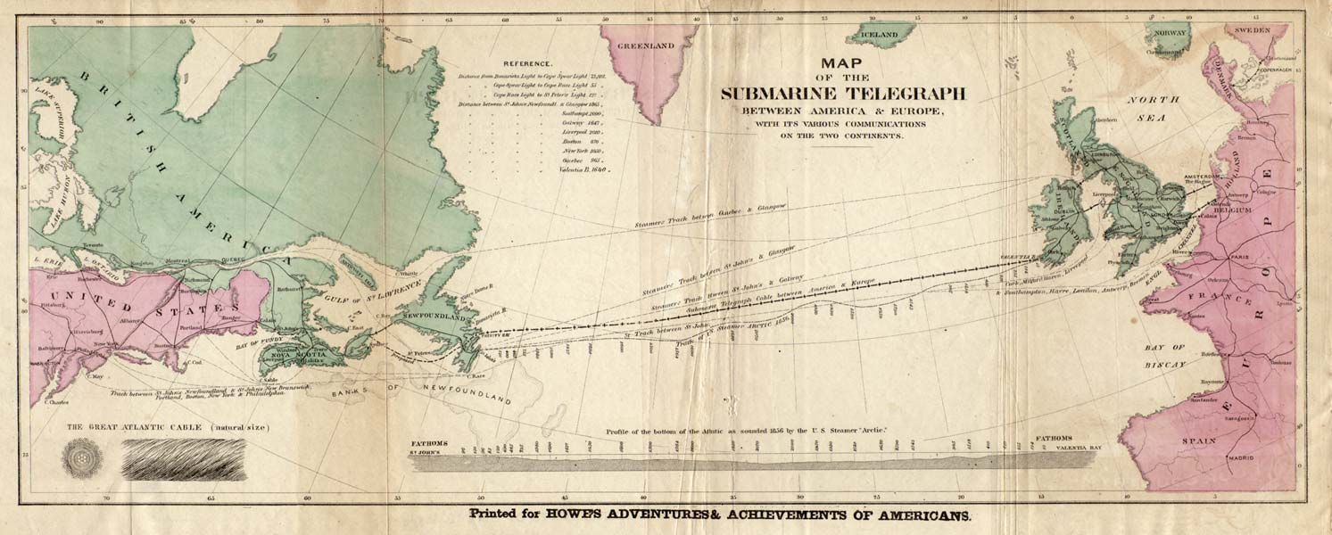

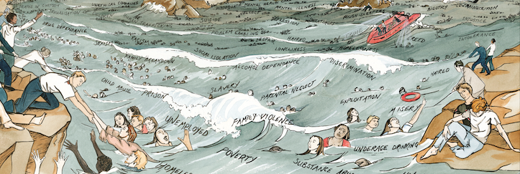

By the year 1900, a quarter of the earth’s surface was ruled by England and more than four hundred million people called Victoria their queen, whether they wanted to or not.

This course on British literature of the Victorian period (1837-1901) will examine how works of culture confronted what was arguably the fundamental social fact of the nineteenth century: the empire.

As we examine the major media forms of Victorian modernity -- novels, drama, poetry, print journalism, visual art, and early photography—we will pay special attention to how those forms began to imagine “the globe” as a knowable entity. This metaphor emerged in the nineteenth century to describe a networked world not unlike our own, as diverse and cosmopolitan as it was oppressive and violent.

How did categories of gender, sexuality, and even personhood change in this vast new framework? How were the conventions of Victorian literature affected by the fact of imperial domination? And was the practice of imperialism itself shaped by the works that described, and sometimes critiqued, it? How did the Victorians imagine their era of globalization? How do we imagine ours?

Required Texts:

Wilkie Collins, The Moonstone (Penguin): 0140434089
George Eliot, Middlemarch (Oxford World’s Classics): 0199536759
H. Rider Haggard, She (Oxford World’s Classics): 0199536422
Additional Readings:

A significant amount of our semester’s reading will be posted on our class blog; these are marked on the syllabus with an asterisk (*). You should plan to budget at least $40 for printing these files in the required hard copy format. Please note that added together the texts for this class represent a significant savings over even the most thoroughly used physics or chemistry textbook. I expect you to purchase the books; print the PDFs in hard copy; read everything on printed paper; and bring all texts to class. If this policy imposes a financial hardship on you, please see me and we can confidentially arrange to have the texts provided at no charge.

Requirements:

Requirements include collaborative thinking, attentive reading, one close reading exercise, one “close-viewing” of an archival visual/cultural object, two analytical papers, and a take-home final exam. Along the way you will also make at least four contributions to the class weblog. There will be occasional reading quizzes, generally unannounced, to ensure our progress on the reading.

Participation: This element of the grade measures your contribution to the collective labor of the class. There are many ways to participate; all of them require diligently preparing the day’s reading and engaging with it actively. Participation on a given day might include contributing to class discussions; intelligently listening to those discussions; coming prepared with questions; and/or posting relevant questions and comments to the blog, in excess of your required postings. Note that you participate when you enable others, not when you take up airtime. Other matters: no cell phones; no texting: only you, your peers, and the work we do together. Note that if you do not have the required text with you, you will be asked to leave the room; this will count as an absence. And please, no computers in class.

Occasional quizzes. (Formats vary.) Simple, fact-based reading quizzes designed to keep everyone on pace; these are part of your participation grade. They may be announced in advance. They may not be.

Four blog posts. (c. 250 words). These are informal but intellectually substantial engagements with our reading for the day. They can take any form you like, and I encourage you to exploit the affordances, or specific capabilities, of the blog format. Summaries will use strategic citation and paraphrase to convey an overview of a given text’s argument as you understand it. Provocations will work more critically, taking a passage and performing a close reading of it to unlock some particular complexity in the writing. You might compare one work with another we’ve read. Or you might pose questions about some knotty element in the reading – a contradiction, a dilemma-- while taking time to thicken it with thoughtful reflections from other areas of the course. The key is to workshop an idea, a hunch, an argument. You don’t need to believe it yet. Protocols and schedules to be determined. “Online participation” refers to your engagement with other class members’ posts -- comments, citation, and other forms of online dialogue.

Close reading exercise. (2 pages, single spaced) Details for this exercise in close reading will be provided, but essentially this is an assignment in the hyperbolically slow apprehension of a textual artifact. Your task will be to take time to appreciate this object in all its dynamic specificity, to show how it works: terms, tips, and helpful suggestions will be provided. You are not meant to argue but to read: your job is to notice everything. Details forthcoming.

Close viewing exercise. (2 pages, single spaced) This assignment takes lessons from the textual close reading exercise and extends them to a physical and/or visual object from the archives: either the physical archives of GU Special Collections or the many electronic archives we will discuss in our library visit. We will discuss what objects fall under this category, but it will not be textual or “literary” in the conventional sense. Still, you will use “literary” reading practices to understand its nuances and appreciate its formal dynamism. Terms and tips to be provided.

Two analytical essays. (4-5 pages, normal-looking font) Conventional essays for an English class, but better. In other words: these are sharp, sustained, and formal engagements with one or more texts covered in class. I will hand out prompts for these papers but you are free, always, to break from my strictures and compose your own questions and topics and then formulate clear hypotheses about them. These analytical efforts should be grounded in close and sustained acts of reading. You may be required to submit the passages you intend to focus on, up to one week in advance of the due date.

Take-home final exam. Open book, open notes, no Googling. This exam is cumulative and is designed to allow you to make creative analytic connections from across the semester. Because of this the best way to study is by being engaged & intellectually present throughout the course. You have 48 hours to complete the test, choosing from among linked sets of essay questions. There may also be identifications and some short answers.

Course Grading Policy:

Your final grade for this course will reflect the quality of work you produce, but also the quality of your participation in the collaborative labor of the course. Thus, thoughtful responses to the texts, active participation in online and class discussions, and level of improvement and sustained effort will all contribute crucially to your final grade. The percentage breakdown is as follows:

Four Blog Posts and & Online Participation 15%
Close Reading Exercise 12%
Close Viewing Exercise 8%
Analytical Essay 1 13%
Analytical Essay 2 15%
Final Take-Home Exam 17%
Participation 20%

Policy on Late Work:
Out of respect for your classmates’ and my own time, turning in late work is strongly discouraged: papers and other assignments will be penalized the equivalent of one letter grade for each day beyond their due date, with the first 24 hour period beginning immediately. Late blog posts will not count, unless cleared with TA or professor in advance. Late exams will not be accepted. Please see me in advance if extraordinary circumstances arise.

Absence and Tardy Policy:

The seminar-style nature of this course makes your presence in class imperative. Your first two absences, whether excused or unexcused, will not be penalized. Every unexcused absence beyond the third will result in a 1 percentage point drop in your final grade, i.e. from 91% to 90%. If you must miss a class session, it’s your responsibility to learn what happened in class and to obtain any of the materials distributed that day. If you know in advance you’ll miss a day when an assignment is due, you must arrange with me another, earlier, due date. You are permitted three late arrivals over the course of the semester. Every two late arrivals after the first three will count as one class absence.

Plagiarism:

Do not do it, ever. If you do, you will (at the very least) fail the course. See the Georgetown Honor System website for guidelines about what constitutes plagiarism and how to avoid it: http://gervaseprograms.georgetown.edu/honor/system/53377.html. Note that in all matters I expect you to observe the Georgetown honor pledge: To be honest in every academic endeavor, and to conduct myself honorably, as a responsible member of the Georgetown community as we live and work together.

Disabilities, Special Conditions, Etc.:

I’m committed to providing whatever it takes to help you be successful in this course. “Georgetown does not discriminate or deny access to an otherwise qualified student with a disability on the basis of disability, and students with disabilities may be eligible for reasonable accommodations and/or special services in accordance with the Rehabilitation Act of 1973 and the Americans with Disabilities Amendments Act (ADAA) of 2008. However, students are responsible for communicating their needs to the Academic Resource Center. The University is not responsible for making special accommodations for students who have not requested an accommodation and adequately documented their disabilities. Also, the University need not modify programmatic, course, or degree requirements considered to be an essential requirement of the program of instruction.” See: http://guarc.georgetown.edu/disability/accommodations/; and please see me early in the term to discuss how I can help.

Writing Center:

Since writing is a valued part of this class, I encourage you to visit the Writing Center (217a Lauinger) early and often, to work with one of the Center’s trained tutors. While you will always be solely responsible for the writing you submit and the Center’s tutors won’t do your work for you, Writing Center tutors can talk you through any stage of your writing process, from brainstorming a thesis and organizing your thoughts to revising, editing and proofreading. It’s an excellent, free service; do make use of it. To set up an appointment, visit http://writingcenter.georgetown.edu.

Guides for Further Study and Research:

Thinking conceptually about literature is difficult, since it entails showing how minute textual details reconfigure concrete historical dilemmas. For your research of matters Victorian, consult the library’s wonderful guide to C19 resources: http://guides.library.georgetown.edu/content.php?pid=236629&sid=1956184. For matters of terminology, your first line of defense is the Johns Hopkins Guide to Literary Theory & Criticism, available through the link above. Second stop is the Stanford Encyclopedia of Philosophy, available with a Google search. For matters of literary history, consult the Oxford Encyclopedia of British Literature or the Columbia Guide to British Literature, both of which are available on campus). Only after that should you bother with Wikipedia. Please stay away from online summaries not mentioned here. And as always, please do not hesitate to contact me with any questions whatsoever about this material. We’re in this together. I’m here to help.
COURSE SCHEDULE: VICTORIAN LITERATURE & GLOBALIZATION

[Please note that the calendar is subject to change; I reserve the right to alter readings as our progress dictates. Readings marked with an asterisk (*) are electronic resources on our class weblog]

Thursday September 3: War and Mediation, Victorians and Us: Alfred, Lord Tennyson, “The Charge of the Light Brigade” (handout)

Tuesday September 8: “The Victorian Age: 1830-1901”*; “Empire”*; What Made the Victorians So Proud?”*; “Queen Victoria’s Little Wars”*; Prince Albert, “Speech at the Mansion House, 1850”*; Anonymous, “Punch’s Own Report of the Opening of the Great Exhibition”*; Alfred, Lord Tennyson, “Ulysses” (handout)

Thursday September 10: “Industrialism: Progress or Decline”*; Friedrich Engels, from “The Great Towns”*; Henry Mayhew, from London Labour and the London Poor*; Elizabeth Barrett Browning, “The Cry of the Children”* (Add/Drop Ends 9/11)

Tuesday September 15: Karl Marx, “The Fetish of the Commodity and Its Secret” and Karl Marx and Friedrich Engels, “The Communist Manifesto.”

Thursday September 17: Fredric Jameson, from Postmodernism; the Cultural Logic of Late Capitalism;* Immanuel Wallerstein, from The Modern World System; Edward Said, “Narrative and Social Space,” from Culture and Imperialism* CLOSE READING EXERCISE DUE

Tuesday September 22: Collins, The Moonstone.

Thursday September 24: Collins, The Moonstone. Marielle Hampe leads class.
Tuesday September 29: Collins, The Moonstone.

Thursday October 1: Collins, The Moonstone.

Tuesday October 6: Collins, The Moonstone.

Thursday October 8: Collins, The Moonstone, concluded. Assorted Mutiny Ballads and Felice Beato Mutiny Photography.*

Tuesday October 13: Melissa Van Vuuren leads class. Meet in Dubin Room, Lauinger Library. ESSAY 1 DUE

Thursday October 15: Sex and Democracy I: Objects and Subjects. John Stuart Mill, from On Liberty (1859) and The Subjection of Women (1869)*; Robert Browning, “Porphyria’s Lover,” “My Last Duchess,” “Fra Lippo Lippi”; Emily Bronte, “I’m happiest when most away,” “No coward soul is mine.”*

Tuesday October 20: Meet in Special Collections, 5th Floor, Lauinger. Sex and Democracy II: Beauty and the Book-Object. Dante Gabriel Rossetti, “The Blessed Damozel,” “Soul’s Beauty,” “Body’s Beauty”*; Christina Rossetti, “In an Artist’s Studio,” “After Death”*; short Book History article TBD*; Barringer et al., “Pre-Raphaelites: A Victorian Avant Garde.”*

Thursday October 22: Sex and Democracy III: Doing As One Likes. Matthew Arnold, from Culture and Anarchy*; C.H. Hazlewood, Lady Audley’s Secret.

Tuesday October 27: George Eliot, Middlemarch.
Thursday October 29: George Eliot, Middlemarch. Marielle Hampe leads class. CLOSE VIEWING EXERCISE DUE

Tuesday November 3: George Eliot, Middlemarch.

Thursday November 5: George Eliot, Middlemarch.

Tuesday November 10: George Eliot, Middlemarch. Laura Otis, “The Webs of Middlemarch”*

Thursday November 12: George Eliot, Middlemarch.

Tuesday November 17: Victorian Networks. G.H. Lewes, from Physiology of Common Life;* Herbert Spencer, from Social Statics*; Gordon Haight, from George Eliot: A Life.* Selections from The Westminster Review. Telegraphic fiction TBD.* ESSAY 2 DUE

Thursday November 19: H. Rider Haggard, She.

Tuesday November 24: H. Rider Haggard, She.

Thursday November 26: NO CLASS / THANKSGIVING BREAK

Tuesday December 1 : Rider Haggard, She. Matthew J. Phillips (Rutgers, English), Guest Lecture.

Thursday December 3: H. Rider Haggard, She. John Martin Handel (UC Berkeley, History), Guest Blog Post.

Tuesday December 8: LAST DAY OF CLASS: “Small wars” and the Diamond Jubilee: Final Reflections.

TAKE HOME FINAL EXAM DUE: Monday, December 14, by 5 pm.

